Install teraform kubectl

sudo nano nginx-deployment.yml

Paste the code :

apiVersion: apps/v1

kind: Deployment

metadata:

name: nginx-login

spec:

replicas: 1

selector:

matchLabels:

app: nginx-login

template:

metadata:

labels:

app: nginx-login

spec:

containers:

- name: nginx-login

image: nginx:latest # Public Nginx image from Docker Hub

ports:

- containerPort: 80

---

apiVersion: v1

kind: Service

metadata:

name: nginx-login-service

spec:

type: NodePort

selector:

app: nginx-login

ports:

- protocol: TCP

port: 80

targetPort: 80

nodePort: 30008 # NodePort exposes service on this port

Then ctrl+o enter ctrl+x

Then

minikube start

kubectl apply -f nginx-deployment.yml

kubectl get pods

kubectl get svc

minikube ip

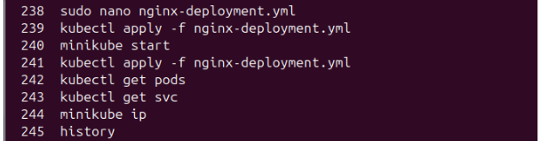

You can see the pod

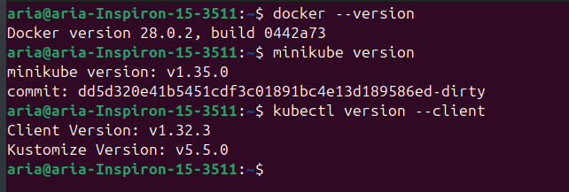

See the ip and port then go to the address bar and search ..  
  
<http://192.168.49.2:30008/>

You’ll find

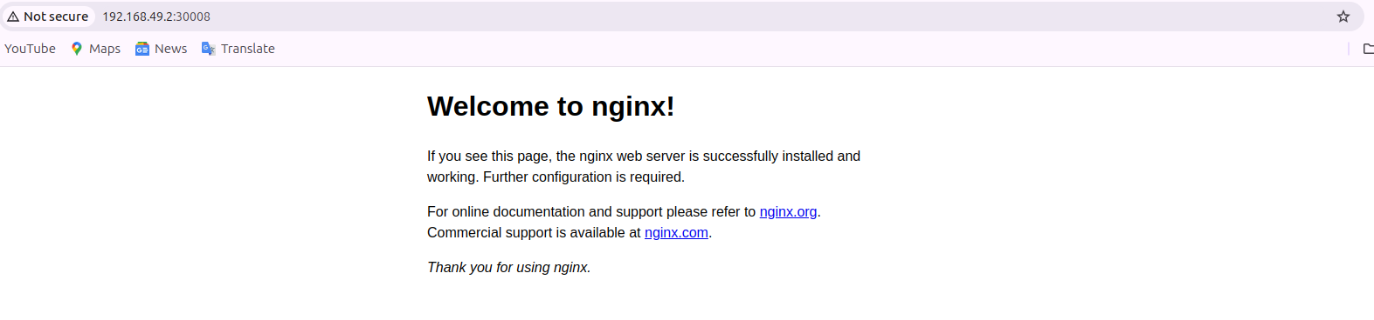

You can also curl to see the output in terminal as:

